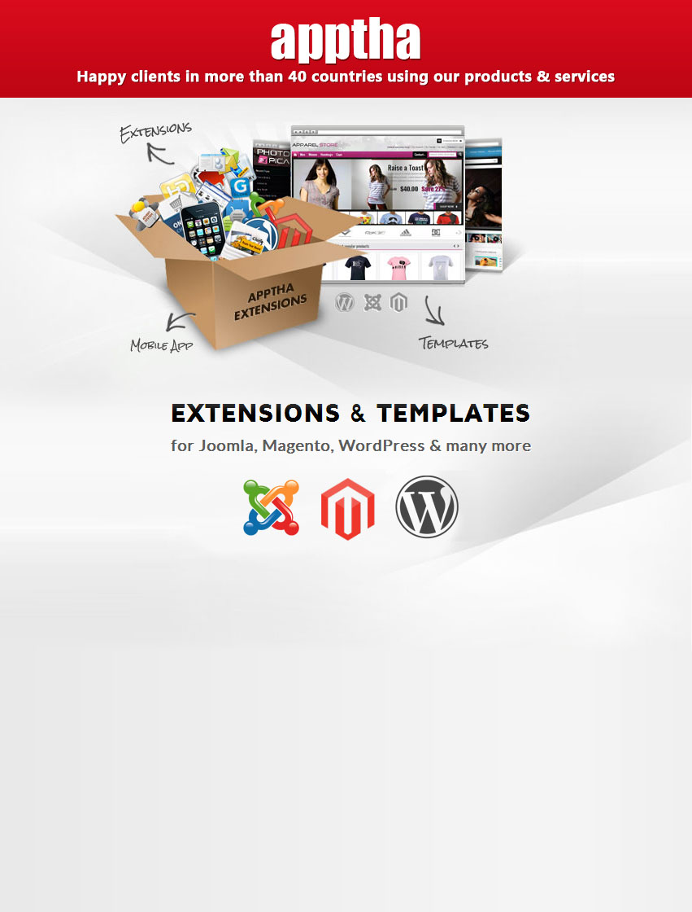

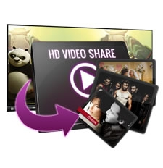

Joomla - HD Video Share

Product Version – 3.4

Compatible - Joomla 1.5, 1.6, 1.7, 2.5 & 3.0

Table of Contents

Preface ………………………………………………………………………………………………….4

About This Document ……………………………………………………………………………………………......4

Updates, Comments, and Suggestions ………………………………………………………………....….4

Disclaimer ……………………………………………………………………………………………………………….....4

Hd Video Share for Joomla ...….…………………………………………………………….....5

Introduction …...………...........………………………………………..……………………..……………….....5

Minimum Requirements ………………………………………………………………………………………….....5

List of HD Video Share Files ……………………………………………………………….….………………....5

Installation Steps ………….……………………………………………………………………….6

Configuring HD Video Share ………………………………..…………………………………8

Member Videos ….…………………………………………………………………………………….………….…...10

Member Details ….…………………………………………………………………………………….……….….....12

Admin Videos ……...…………………………………………………………………………………………….….....13

Category …….......…………………………………………………………………………………………………....…16

Player Settings …………………………………………………………………………………………………….......17

Site Settings ……………………………………………………………………………………………………..........20

Google Adsense ….........................................................................................21

Video Ads ….................................................................................................22

Home Page Look ….....……………………………………………………………………….……23

Client side settings …..........……………………………………………………………………………..…......24

My Videos …..................................................................................................26

Logout ….......................................................................................................31

Contacting Us ………………………………………………………………………………………..33

Preface

About This Document

This document provides information on how to download, install, configure, and use Video Share for Joomla.

Updates, Comments, and Suggestions
Please forward your valuable comments, suggestions, or questions about the information contained in this document to assist@apptha.com.

Disclaimer
Apptha reserves the right to add, remove, or modify business models or processes related to packaging, selling, marketing, developing extensions and themes of Apptha.com, at any time and without prior notification.
Apptha reserves the right to add new features to its products based on research and market needs.
Apptha reserves the right to remove any feature of its products that does not fulfill expectations.

HD Video Share for Joomla

Introduction

The HD Video Share is a Joomla extension for videos sharing with built-in HD Flv Player. Users can add videos from local disk, YouTube and from any URLs. One big reason for the success of our extension is because of regular updates and features. HD Video Share always aims at top customer satisfaction. Though we don’t provide the source file of the player we are flexible enough in customizing the player based on the customer request at very low cost. We trust you will enjoy the process and can then look forward to tailoring HD Video Share to your own specific requirements.

Installing and using HD Video Share is generally straight forward, getting your perfect Web site takes a lot more effort but there is much, as you will discover, that has been done to make the process easier along the way. This component comes with few free modules. By using these free modules, you can change your Joomla website as video sharing website like YouTube and Vimeo.

Minimum System Requirements

- To successfully install and use HD Video Share you must have a fully operational Web server (Apache is the optimum) with Joomla! Installed.
- HD Video Share has been successfully tested on many variants within the main three OS for Windows, Linux, Apple Mac OSX with Joomla installed. It may well work on other platforms but this is less well documented.
- HD Video Share is also regularly used and tested through the main Web browsers available such as IE6+, Firefox 1.5 +, Safari, and Opera but it may also work with others.

List of HD Video Share Files

HD Video share package is available for Joomla 1.5,1.6,1.7, 2.5 and 3.x. Only logo and logo configuration are the major difference between free and paid package. Your free download includes the following modules:

1. HD Video Share Search Videos.
2. HD Video Share Featured Video.
3. HD Video Share Video Category.
4. HD Video Share Recent Videos.
5. HD Video Share Related Videos.
6. HD Video Share Popular Videos.

Installation steps for Joomla 1.5

It is very easy to install the downloaded files.

- Log on to Joomla Administration page.
- Go to Extensions -> Install/Uninstall -> Choose file.
- Select the component downloaded and click Upload File and install.

Now the component will get installed successfully. In single installation you will get all the six modules and components.

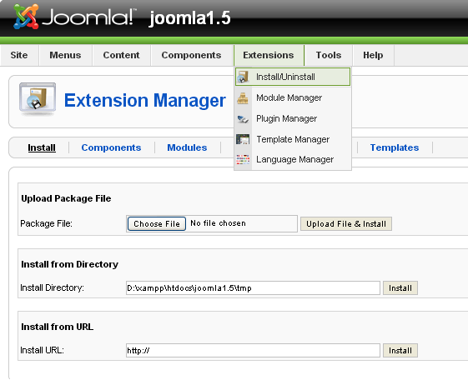

Installation steps for Joomla 1.6,1.7,2.5

- Log on to Joomla Administration page.
- Extensions -> Extension Manager--> Choose file.
- Select the component downloaded and click Upload File and install.

Now the component will get installed successfully. In the single installation you will get all the six modules and components.

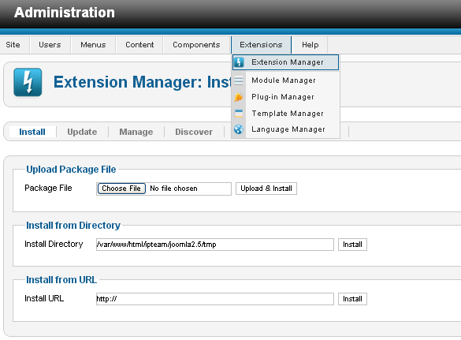

Installation steps for Joomla 3.0

- Log on to Joomla Administration page.
- Extensions -> Extension Manager--> Choose file.
- Select the component downloaded and click Upload File and install.

Now the component will get installed successfully. In the single installation you will get all the six modules and components.

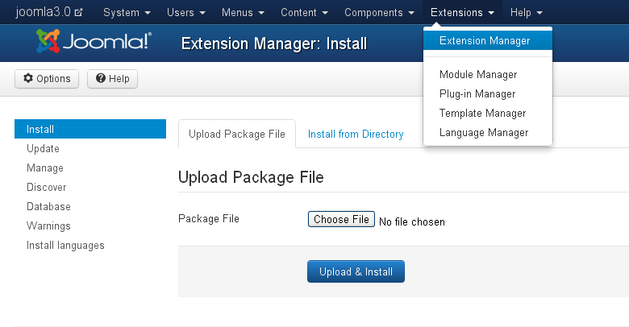

Configuring HD Video Share

To assign component in Joomla 1.5

Log on to Joomla Admin -> Menus -> Your_Menu_name and select the menu where you want to assign the component, Click Change Type -> Select HD Video Share from the list -> Click Index (Default Layout) -> Name the Menu ->Save.

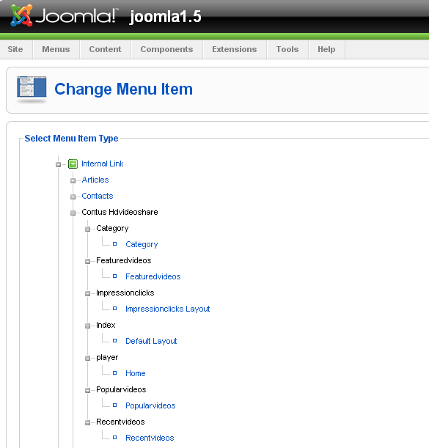

To assign component in Joomla 3.0

To assign this component in a menu, Log on to Joomla Admin -> Menus -> Your_Menu_name. Here select the menu item where you want to assign the component, Click "select" -> Select "Home" under Contus HD Video Share from the popup.

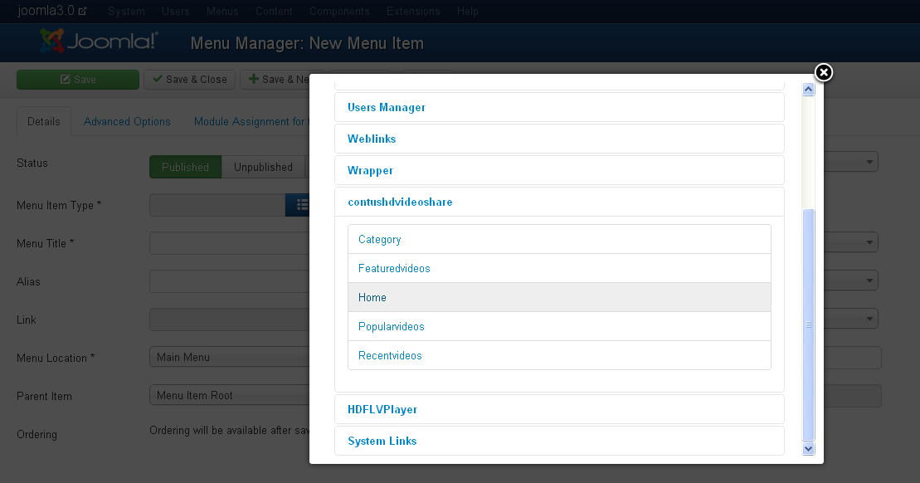

Apart from installation and assigning the component to the menus, remaining all the steps is same in Joomla 1.5, Joomla 1.6, 1.7, 2.5, and 3.0

Member Videos

This is the primary tab, It lists all the videos added by the users from the front end. On this page you can do the following.

1. You can sort the videos by dragging on it.
2. You can modify the comments under comment column.
3. The corresponding streamer name, streamer path, videos link, thumbnail link for that member added will be display under the responding columns.
4. Also can view the postroll ads, preroll ads, midroll ads videos.
5. You can search/Filter videos of any user
6. You can view Ratings and Number of views of any video.
7. You can view/delete videos of any particular user.
8. You can either choose publish or un-publish any videos added by users
9. You can either choose enable featured or disable featured. It has been included in the features videos list.

Joomla 1.5:

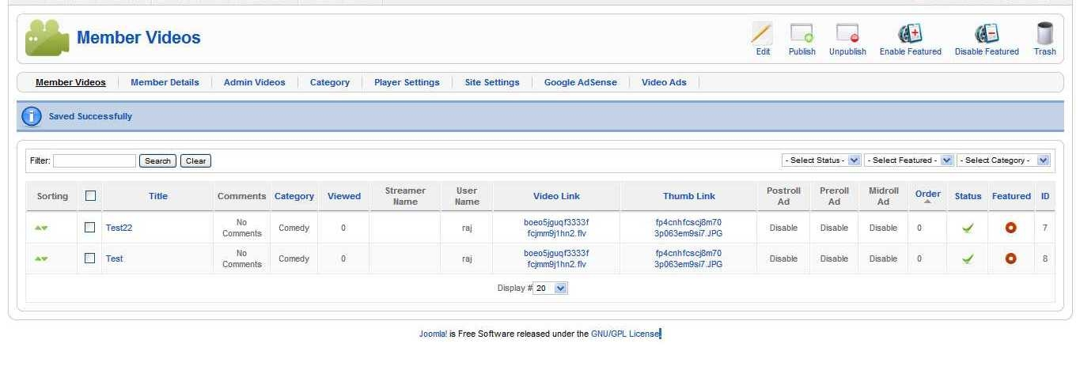

Joomla 1.6:

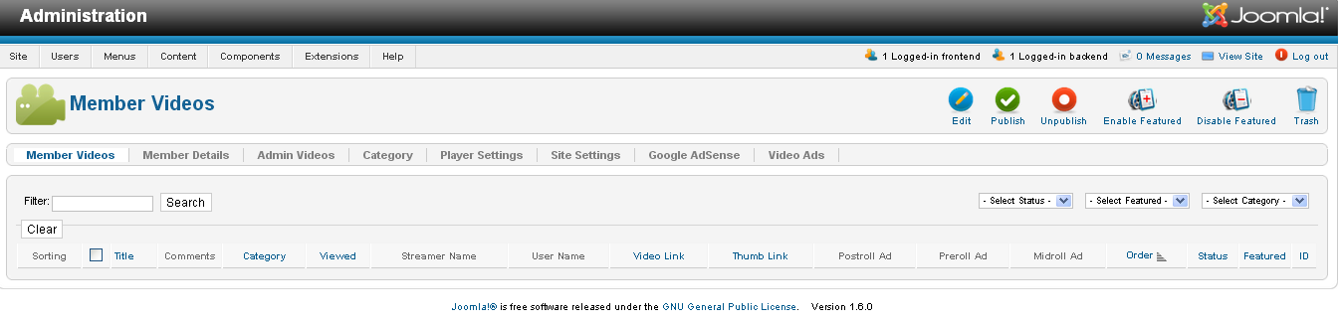

Joomla 3.0:

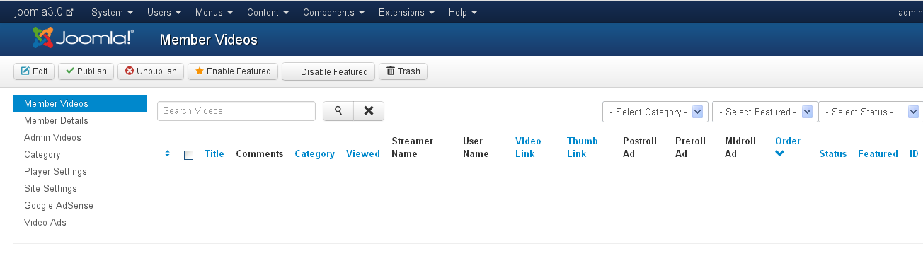

Member Details

In this section, admin can view all the details of the sign-up users and can control them by active or de-active.

Joomla 1.5:

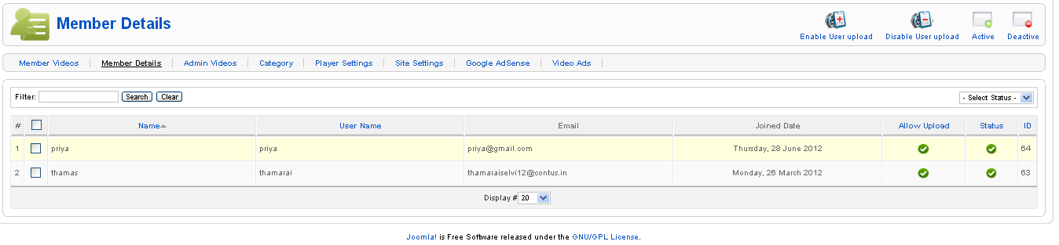

Joomla1.6:

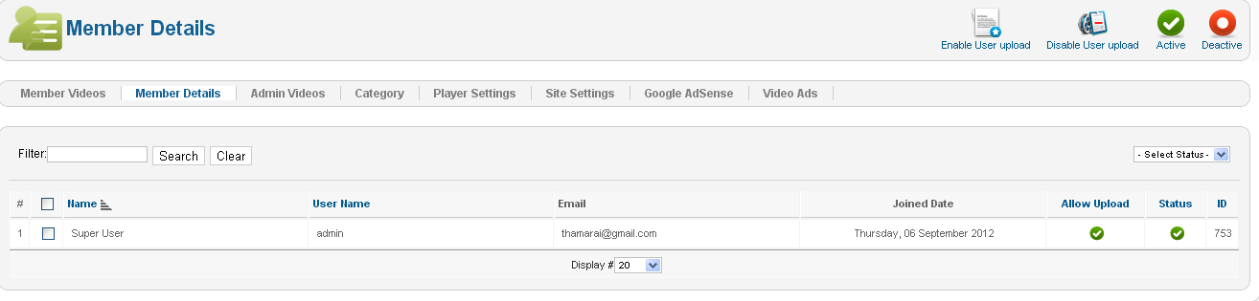

Joomla 3.0:

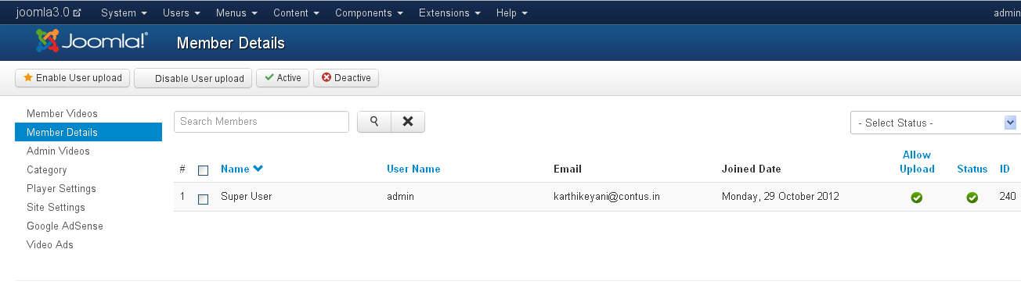

Admin Videos

• This is the place where admin can add videos to HD Video Share categories. HD Video Share accepts both streaming and normal way of playing videos. By default it is set to None where you can add videos through following methods Upload, Direct URL, YouTube URL and FFMPEG.
• After adding the videos via any below methods, kindly update the video info section where you can add Title,Description, Target URL for the video, assign Category, sort order(recently we added Ajax sorting where you can sort the videos simply by Click and drag from the Videos tab), enable post roll and pre roll ad for the respective videos.

Adding videos through Upload method:

Four fields will be visible when Upload is selected.

1) If you want to give the users an option to switch between HD and Non HD videos you have to upload two formats of videos.
2) If you don’t want to give the users a choice then you can upload any one of the video, either HD or Non HD. Leave the second field “Upload HD Video (optional)” as blank.
3) After uploading the videos, you can also have options to upload thumb image and preview image for the corresponding videos.
4) Below this, there is video info section where you can add Title, Description, Target URL for the video,Assign Category, sort order (recently we added Ajax sorting where you can sort the videos simply by Click and drag from the Videos tab).
5) Also, enable post roll and pre-roll ads for the videos.

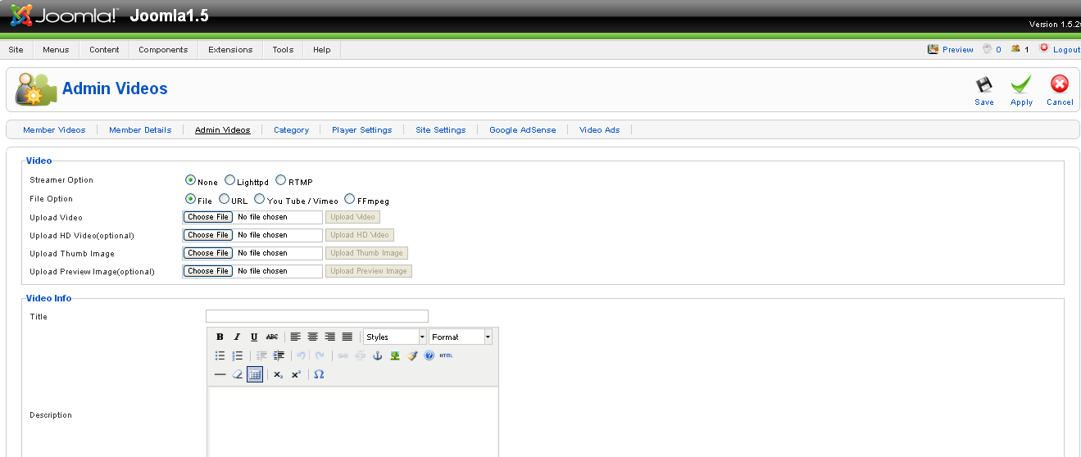

Adding videos through URL method:

- Upload the videos and images through FTP to any location on your web server.
Example: you can add videos and images in the respective video and images to videos folder on your web server and provide the absolute path here.

E.g.: http://www.yourdomain.com/videos/video.mp4 http://www.yourdomain.com/images/image.jpg

Adding videos from YouTube:
To avoid bandwidth consumption from your web server you can also add videos to the YouTube and provide YouTube link here.

Adding videos through FFMPEG:
- Before you start uploading the videos using FFMPEG, make sure you provided the path of your FFMPEG on the "HD Video Share Settings".
- If you are not sure about the path to mention, kindly contact your hosting provider for the details.
- After you set the path to FFMPEG you can upload any HD files to convert it to lower resolution.
- The Thumbnail image and the Preview image will be create automatically.

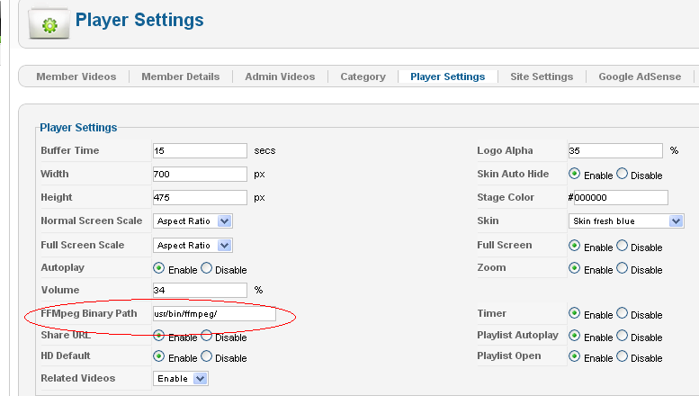

Adding videos through Lighttpd:
Same as like adding videos through URL method. Provide the path to Non HD or HD videos or both the path (if you need). Also provide the path to the thumb and preview image.

Adding videos through RTMP:
• Provide the Streamer path which would be rtmp://edge01.fms.dutchview.nl/botr and the video URL would be bunny.flv from the below RTMP file rtmp://edge01.fms.dutchview.nl/botr/bunny.flv
• Also there is a field for thumb and preview image URL which you can mention streamerpath = [protocol]/[servername]/[application] URL=[streamname]
1) [protocol]: You can use the following protocols: rtmp, rtmpt, rtmpe, rtmpte, rtmps
2) [servername]: this is the IP Address, or the domain name of your server. (i.e. localhost)
3) [application]: use “vod” unless you have changed the name of the folder
4) [streamname]: use the name of your video file (including the extension).

EXAMPLE URLS :
rtmp://localhost/vod/mp4:mystream.f4v
rtmpe://localhost/vod/myvideo.flv

Category
Here, you can control the front end categories to make it display. You can create new category and modify the existing categories. Users can choose any number of categories while adding videos.

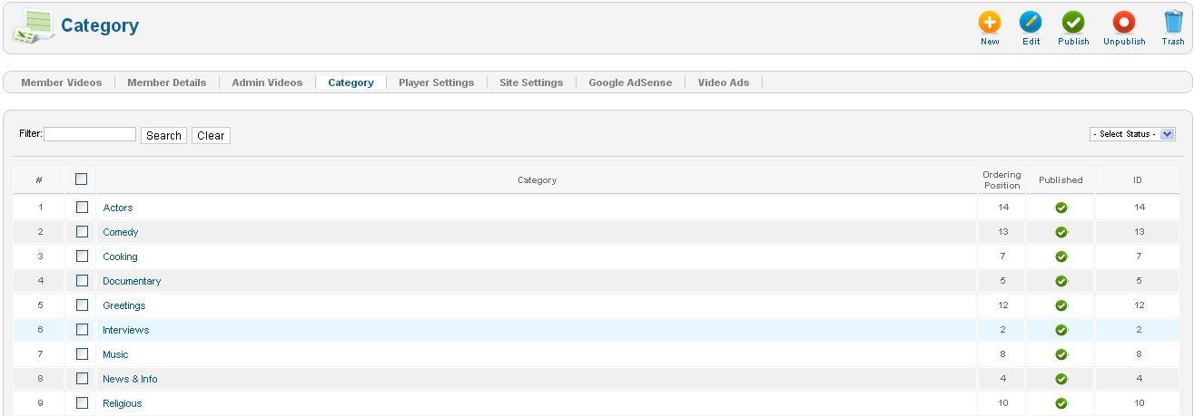

Player Settings
This is the global settings for HD Video Share.
Modify player settings by clicking “Edit" button at the top right.

Player Settings

- Buffer time - You can set the buffer time for the player to save portions of a streaming media file to local storage for a playback.
- Width & Height - You can specify the width and height of the player in pixels (px)
- Normal screen scale - You have three options to set. They are,
1. "Aspect ratio" which controls the player size proportionally,
2. "Fit to screen" plays the video to the player size that declared,
3. "Original size" plays in original video size irrespective of the player size declared
- Full screen scale - This setting affects only on full screen mode
- Autoplay - This option is used to play the videos one by one continuously without clicking on next video.
- Playlist Autoplay - Its used to play all the videos from playlist continuously.
- Volume - You can set the default volume level when the video plays
- Playlist open - You can set playlist to open / close always by enable / disable this option

- Vast- If you partnered with video ad network to show ads for your video, you can enable this option.
- Logo alpha - You can set the transparency rate for the logo on the player.
- Skin auto hide - You can enable or disable the player skin to be displayed on the player
- Stage color - Set the background color for the player in the format ffffff
- Skin - Here you can find the available skins according to your website design
- Fullscreen - Fullscreen button can be enable/disabled from here
- Zoom - Zoom button on the player control can be disable / enable here
- Timer - Timer on the player controls can be enable / disable
- Share URL - Share button on the player can be disabled from here
- HD Default - You can set the HD videos to play by default. Make sure you have declared HD video path / uploaded HD videos.
- Related Videos - You can enable/disable related videos display within player (as playlist)
- Ads Type – You can have two types of video ads in your player.
1. Intermediate Ad
2. Pre-roll/post-roll Ads

To enable “Intermediate Ad”, select your "Ads Type” as “Intermediate Ad ”. Now you will get text box to enter “Intermediate Ad XML Path”. Your XML Path will look like the following one. Eg: http://adserve.atedra.com/vast/demo.xml

If you enabled Intermediate Ad then your Pre-roll and Post-roll ads will not be played in the player. If you want to display Pre-roll and Post-roll Ads, then select your Ads Type as “Pre-roll/post-roll ”

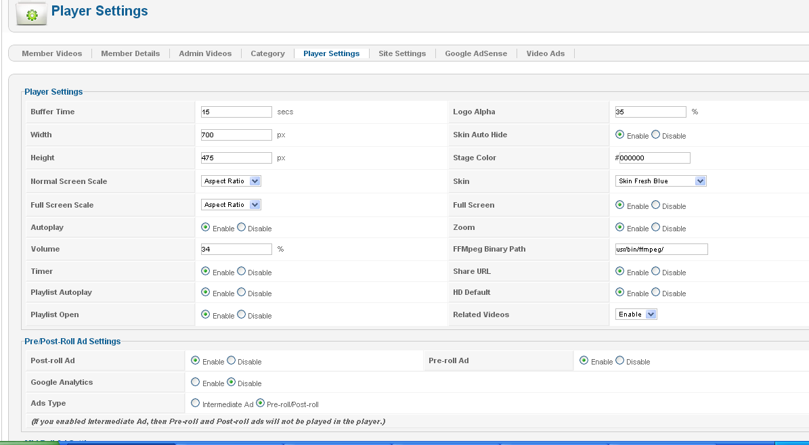
Logo Settings

- Demo logo will be removed only if you provide the license on the License Key field which you can obtain by purchasing it online from our Website. If you are using the free version, simply click on Buy Now button to purchase the license.
- Then you can upload the logo by clicking change button. Allowed extensions are png, gif, jpeg, jpg.
- Click on Right hand side “Edit” to change default settings.

- Logo URL : Enter your website URL, so that when someone click on the logo it will take them to the website that you have mentioned here.
- Logo Position : You can set the position of the logo. You can place the logo in top left / right and bottom left / right.

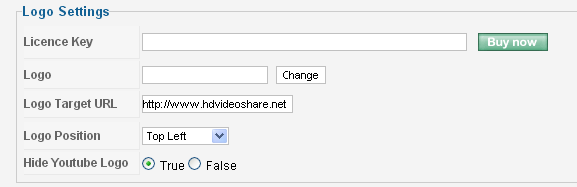

Site Settings

Here, you can control the number of rows and columns of the thumb images to be display in the front end for the following videos and views.
• Recent Videos
• Featured Videos
• Popular Videos
• Category View
• Related Videos
• My Videos
• Member Page View
• Side Popular Videos
• Side Featured Videos
• Side Related Videos
• Side Recent Videos

Here you have option to enable/disable for homepage popular, recent and featured with respective specified count of rows and columns and order.
Also, have yes/no option for Video Upload Option to Members, Members Login/Register, Display Ratings, and Display Viewed.
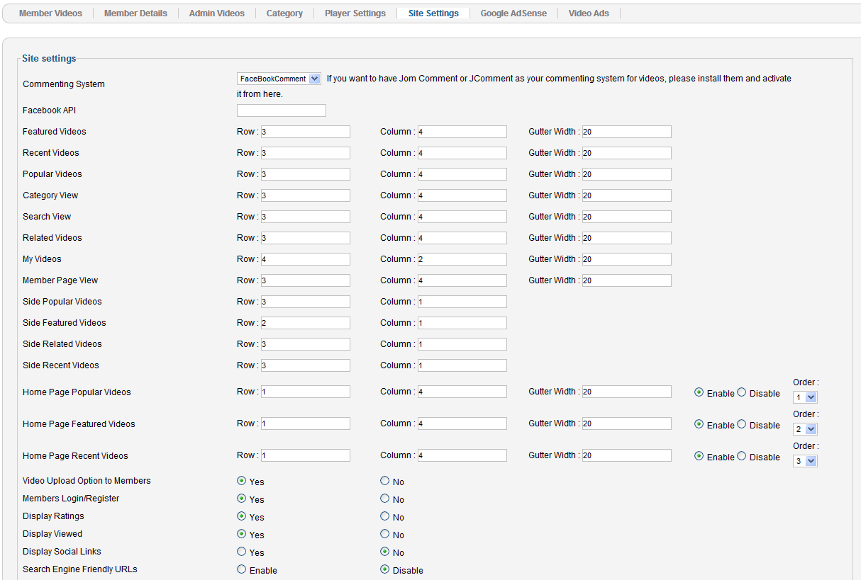

Google AdSense

If you have account on Google Adsense, You can configure it here. To use it, you need to enable "Publish" on this page to display the ads in components, modules and plugin. You can do the following configuration for Google Adsense,
- Option for showing the ads always and close it in the specified timings.
- Option to set the timings to reopen the ad again once it gets closed.

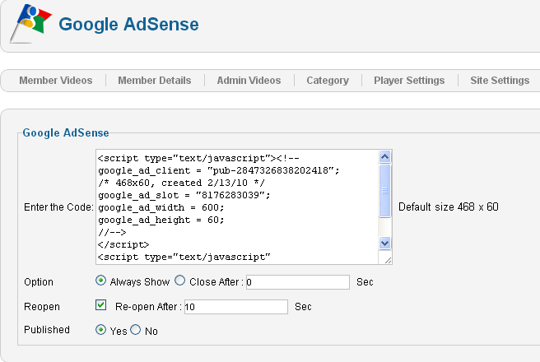

Video Ads

Under this tab, you can add ads for preroll/postroll or midroll. Here you can upload or provide URL videos for ads to make it to be display it as pre roll or post roll ads or mid roll ads while adding videos.
Also you can provide the target URL if you wants your user to be redirected to the particular site when clicks on the videos ads.
- Click hits URL - Here you can get the view count of how many times the ad shows on the player with the video.
- Impression URL - Here you can get the view count of how many times the user clicks on the ad and goes to the target URL.

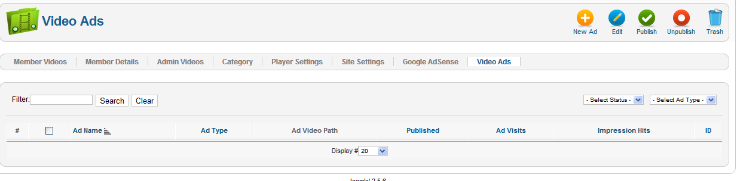
Home Page Look

This is how HD Video Share Home page will be displayed based on the Joomla template that you have selected.

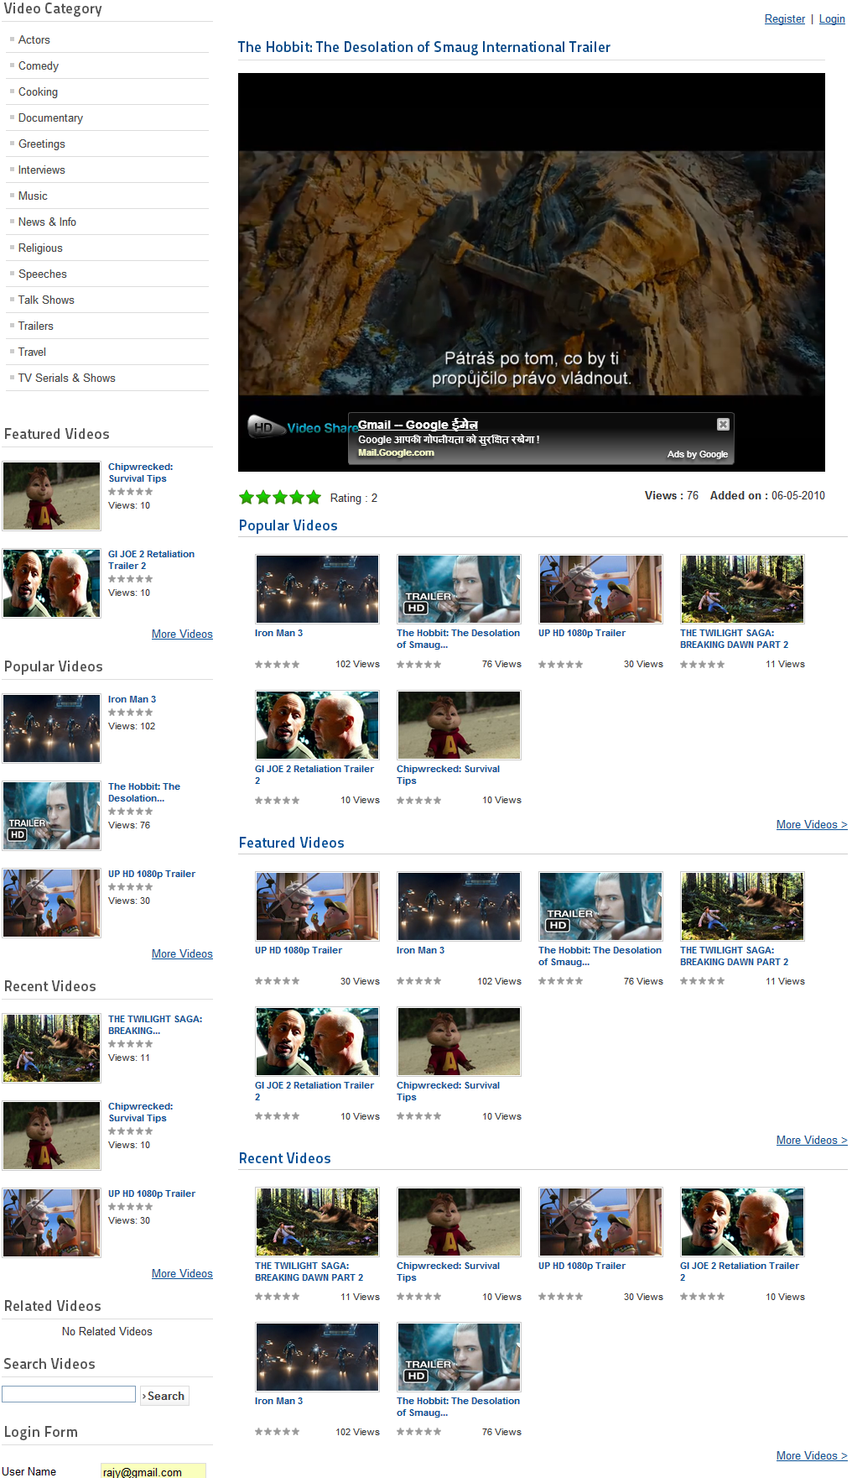

Client Side Settings

Login:
Separate Signup/Login is not needed to register with HD Videos Share. Users can login using Joomla Username and Password, i.e. login into Joomla website and access HD Video Share application.

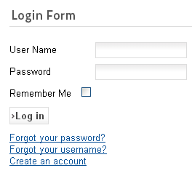

The above is the sample login form. The Login Form look and place is based on your Joomla Template and your Joomla configuration.

Registration Form:

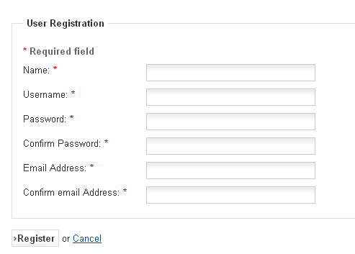

- Username: This is the username you will be identified by in the HD Videos Share. It must be shorter than 6 characters. It is not possible to use the name of an existing HD Video share member.
- Password: You must choose a password that is at least six characters long. The password will be stored Encrypted in the database of the HD Video Share, so it is impossible even for someone with access to the database to know your password.
- Confirm password: To exclude mistakes (for example mistyping) you have to retype your password.
- Email address: You need to enter a valid email address for the case that you forget your password. Once you have registered, you will be able to login with this username and password.

Once you have registered, you will get the following links “MyVideos” and “Logout”.

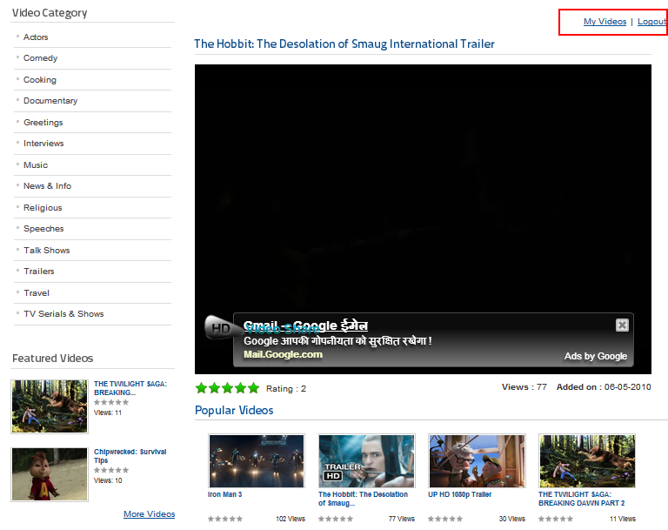
My Videos

My Videos tab allows you to upload videos in two ways: Upload video file or Upload via URL or Youtube and Vimeo Videos. Refer screenshots below.

Add videos through Upload option

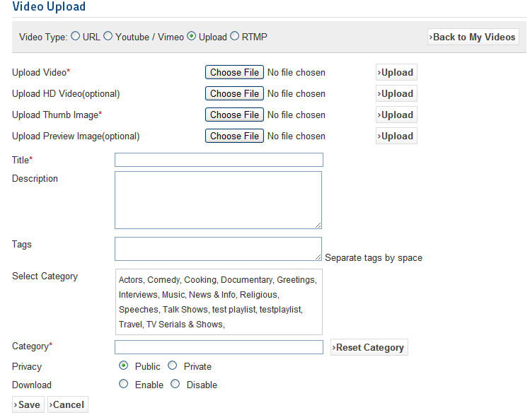

Add your videos via URL link

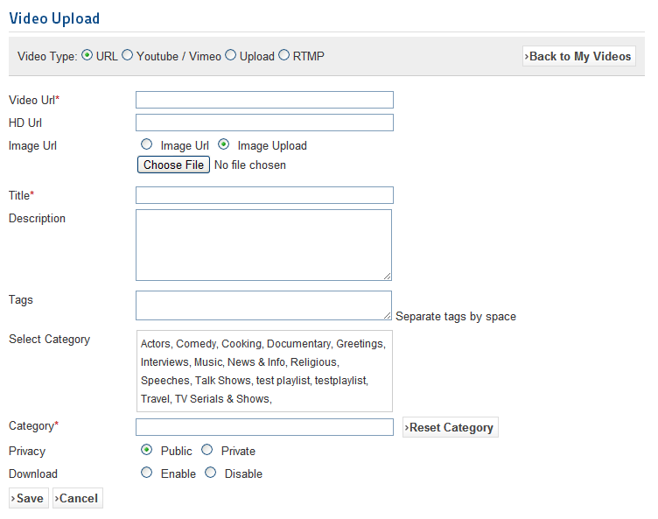

Add Youtube and Vimeo Videos

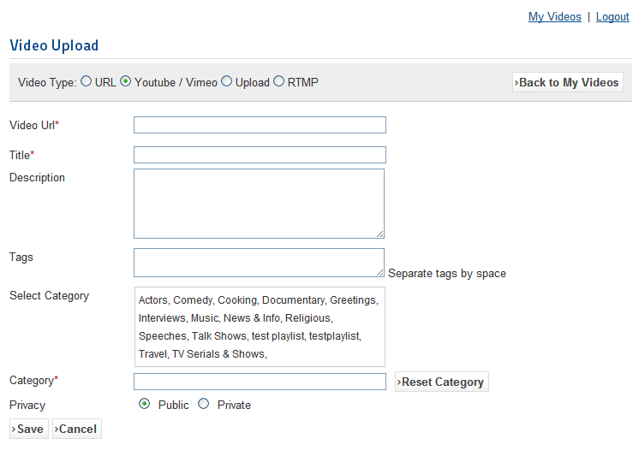

Add RTMP Videos

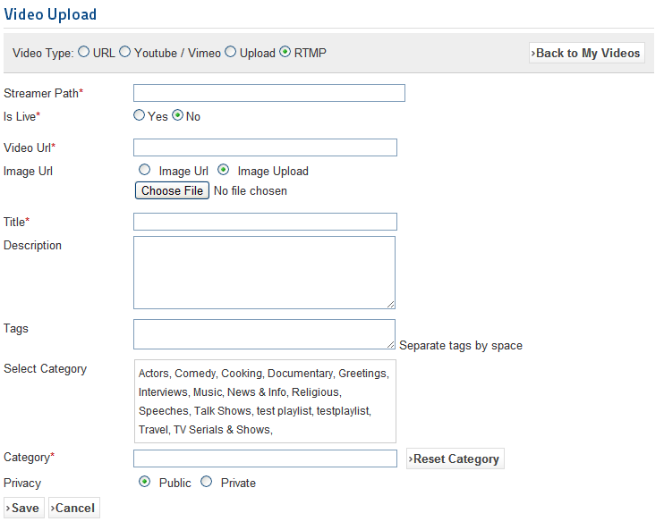

Here you can view your uploaded videos. Also, here you can modify your respective videos. In this page, search module is available to search your videos in simplest manner.

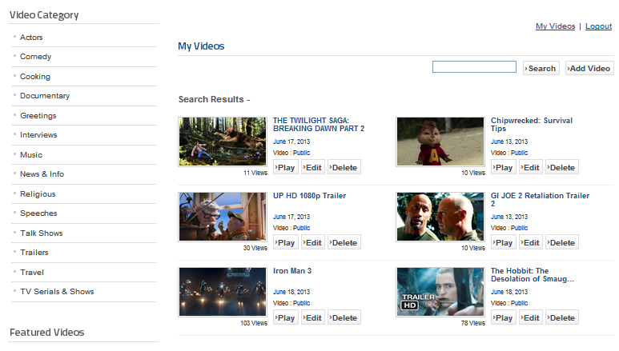

Logout

To logout use either Joomla sign out/ logout option or Sign out above Player. You will receive a Login module. Simply confirm by clicking on Logout.

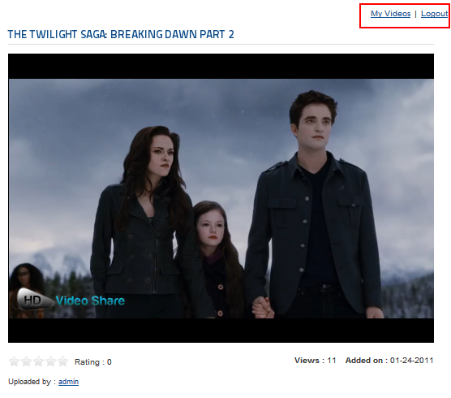

Contacting us
Our support team is happy to help with any questions about using product. You may contact our support team through support forum& support tickets.

Your question may already be answered!
Forum: www.apptha.com/forum

Before you send us an email or raising tickets, take a look at Apptha.com/forum for any technical issues, common questions and more. We may have already answered your question.

Raise tickets for your specific questions!
Tickets: assist@apptha.com

Send an email to our support team to get answers to your specific questions. Our team will work to respond to your query promptly.

The best place to discuss about additional features!
Email: bdm@apptha.com

